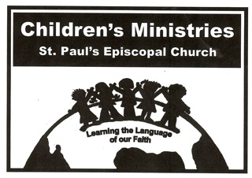Parent’s Signature

Child’s Full Name __________________________________________________

Child’s Date of Birth _________________________________________________

Parent/Guardian(s) Names _____________________________________________

Parent Email Address _________________________________________________

Approximate Date of Child’s Baptism ___________________________________

My child will participate in the Communion Celebration at the 9am Service on May 6th.
Please Circle OneYesNo

I/We will attend the Parent Communion Class/Clergy Forum on April 22th at 10:10am in the Chapel
Please Circle OneYesNo
Number of Parents attending1234 or more

2018 St. Paul’s

Communion Class

Registration form
All Baptized Children aged 1st Grade and up are welcome

I, ______________________, parent/guardian of ____________________________ grant permission for my child to attend Communion Classes on April 15th, 22th, and 29th, from 10:10am-11:00am. I understand that attendance at each class is important and will do my part to make sure my child attends each class.

______________________________________________ _________________________
Parent Signature Date

Child’s Signature
I, ___________________________, will participate in Communion Classes on April 15th, 22th, and 29th from 10:10am-11:00am. I will be respectful to the clergy, my teachers, parent volunteers and other class members and will abide by St. Paul’s Children’s Ministries Behavior Expectations Policy.

_____________________________________________ ______________________
Child’s Signature Date

Please return signed forms to Christine Ingram prior to April 1, 2018 . Thank you!

